Name: ______________  **Social Studies 10**

**/20**

* Circle for the best possible answer to the questions below or answer the question in the space provided.

1. The **winner** of the War of 1812 was:
2. The French b. The British c. The Americans d. It was a stalemate
3. Which of the following people were **not** involved in the War of 1812?
4. Tecumseh b. Laura Secord c. General Montcalm d. General Brock
5. The **primary** goal of this act of government was assimilation:
6. Proclamation Act b. Quebec Act c. Constitutional Act
7. The **primary** goal of this act of government was biculturalism:
   1. Proclamation Act b. Quebec Act c. Constitutional Act
8. The **primary** goal of this act of government was to divide Canada into two Provinces:
   1. Proclamation Act b. Quebec Act c. Constitutional Act
9. The term **Anglicization** means:
10. To convert to English ways c. To become Anglican
11. To form a democracy d. To adopt foreign beliefs
12. Acts of Government that **encouraged** the people of the **13 colonies** to revolt against Britain were known as the:
13. Riot Acts b. Intolerable Acts c. Tea Act d. Republican Acts
14. Under the **Constitutional** **Act**, this level of government held the **most** power in Canada
    1. The voters c. Legislative Council
    2. Executive Council d. Lieutenant-Governor
15. The **victorious** general at the battle for Quebec City in the 7 Years War was:
16. Moncalm b. Martin c. Brock d. Wolfe
17. The peace treaty that ended the **7 Years War** was the:
18. Treaty of Paris b. Treaty of London c. Treaty of Quebec d. Treaty of Ghent

11. Today Upper Canada is known as: ______________________________.

12. Lower Canada is known as: ___________________________________.

13. Define the term “Bicultural”:_______________________________________________

__________________________________________________________________________.

14. Who or what does “Crown” refer to (remains the same to this day):

_______________________________________.

15. Define Crown and Clergy Reserves: _________________________________________

_________________________________________________________________________.

16. Explain why the Clergy Reserves only benefited the Protestant Church and not the Catholic Church:

________________________________________________________________________

________________________________________________________________________.

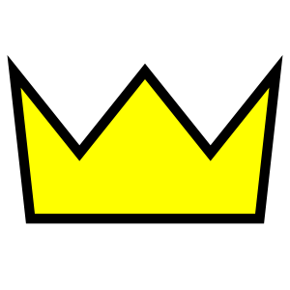17. Define the term Representative Government: ________________________________

_________________________________________________________________________.

18. Define the term Appease and provide and example of how I was used on the French by the British in Canada:

_________________________________________________________________________

_________________________________________________________________________.

19-20. Label the headings of the levels of government in the Diagram below based on the Constitutional Act in Canada. (2marks)

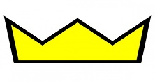

c