Name: _____________________ Due Date: Friday December 16th 2016

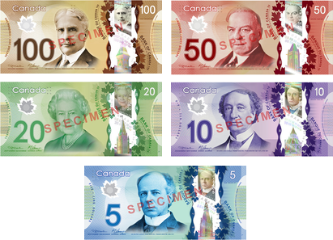
Canada is Born:
Designing our Currency

Objective: Develop and understanding of the
significance of commemoration
in Canadian History.

Info:
- In 2013 the Bank of Canada fully released its polymer
(synthetic vs paper) series of Bank Notes.
- The decision for the imagery was dictated by the Federal
Government and was arguably less inclusive than previous releases.
- See for info: http://www.bankofcanada.ca/banknotes/bank-note-series/

Your task:

- Create TWO brand new bank notes for the Bank of Canada that reflect your idea of what commemoration should be in Canada.
- You can choose from $5, $10, $20, $50, $100 bills.
- You can pick ANY relevant person, event, scene or image to design your bills with.
- Be creative and select important historical events you feel are worthy.

REQUIRED INFORMATION - Each Bank Note Needs the following:

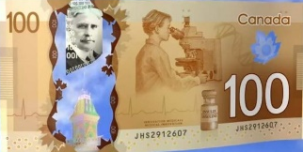
Front:
- Main Image with design (person, place, event, scene)
- Monetary Value
- Colour / Optional security details.

Back of Card:
- Secondary Image with design (person, place, event, scene)
- Colour / Optional security details.

Summary:
- Describe why you designed each note and picked your images for the bills the way you did.
- ½ page typed for each note.
- Display evidence of research for the Historical events, people or places you displayed.
- Describe why they are important to you and relevant to Canadians.

- This is an individual assignment.
- Be as creative and colourful! Include any interesting aspects you feel are important.
- Graded out of 25 marks – Hand in the rubric on the back of this page with the notes.

    - Assignment may be done electronically: email to vmartin@ndrs.org (save paper)
    - Or submitted to Mr. Martin in room 204 or in class on December 16th.

Name: ___________________ Block: ___________ Date: ________________
Canada Bank Notes Rubric | Exceeds Expectations | Meeting  Expectations | Approaching Expectations | Does Not Meet Expectations | Section Total:
Neatness and Appearance  - Notes are aesthetically pleasing.  - Displays use of colour, organizing and includes a main image.  - Images are appropriate. |  |  |  |  | / 5
Content  - Any two of the $5, $10, $20, $50, $100 bills present.  - Each bill has 2 sides, with one main image, event, scene or person depicted per side.  - Images are meaningful and relevant to Canadians |  |  |  |  | /10
Creativity and Originality  - Notes display uniqueness, originality and creative thinking |  |  |  |  | / 5
Summaries  - The rationale (reason you picked) each note is explained (1/2 page typed each).  - Summaries are accurate and relevant.  - Summaries display evidence of research and understanding of the events you chose. |  |  |  |  | / 10
Additional Comments: |  |  |  | Total: | /25

