Mr. Martin SS 10 Name: ___________________ Date: ______________

Immigration: Push and Pull Factors

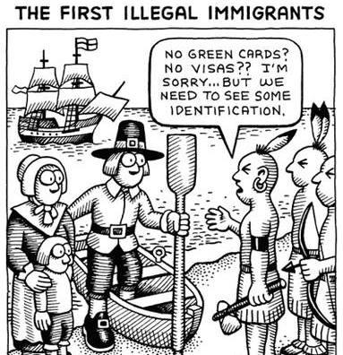

BACKGROUND – Immigration vs Emigration

- The process of leaving one’s country of residence to permanently move to another place is
known as emigration or emigrating. Emigrants leave a country. For example Mr. Martin
emigrated from (left) Ireland.

- A person that has left their country of residence to permanently live in another country is
known as an immigrant in that new country. Immigrants enter a country. For ex: In Canada
Mr. Martin is living as an immigrant.

PUSH FACTORS:

Define Push Factor in your own words: _______________________________________________________

_______________________________________________________________________________________.

Brainstorm as many reasons as you can a person could be “pushed” from their homeland: (minimum 10)

PULL FACTORS:

Define Pull Factor in your own words: _______________________________________________________

_______________________________________________________________________________________.

Brainstorm examples of pull factors that exist in Canada today (Minimum 10)

What pull factors existed during the time period 1815 – 1914? (Minimum 7)

{{Turn to page 252 in Horizons to read more about Push and Pull Factors. }}

RESTRICTIONS AND OBSTACLES:

Immigration can be a stressful and traumatic experience for people (especially when people feel forced). In Canada this process has also be marred and darkened by a history of discrimination and favouritism.

Aside from having to spend their life’s savings, many immigrants were mistreated upon arrival. They were underpaid, abused ignored, left to fend for themselves and in some cases turned around at port.

Can you think of any famous examples? ______________________________________________.

We will discuss this History again later on in this unit.

EXIT SLIP QUESTION:

- Imagine yourself as an emigrant from any European nation in the 1890s. There has been a recent drought and now your family is starving. In order to survive you must leave and start over in a new country. Where in the world would you choose to go? In your answer state the country you are pretending to be from, your destination, and 3 concrete reasons why you would select that particular destination as your new home.

