Mr. Martin SS 10 Name: ___________________ Date: ______________

The Best of the Rest: Immigration to Canada in the 1800s

- Define Open door policy: ____________________________________________________

_________________________________________________________________________.

- Define Underground Railroad: ________________________________________________

_________________________________________________________________________.

- Who were the following people and why were they significant in terms of immigration?

Wilfred Laurier: ________________________________________________________

__________________________________________________________________________.

Clifford Sifton: _________________________________________________________

__________________________________________________________________________.

Harriot Tubman: _______________________________________________________

__________________________________________________________________________.

- Who Arrived? #1:

Push Factors for this group: ___________________________________________________.

Pull Factors for this group: ____________________________________________________.

#2:

Push Factors for this group: ___________________________________________________.

Pull Factors for this group: ____________________________________________________.

#3:

Push Factors for this group: ___________________________________________________.

Pull Factors for this group: ____________________________________________________.

#4:

Push Factors for this group: ___________________________________________________.

Pull Factors for this group: ____________________________________________________.

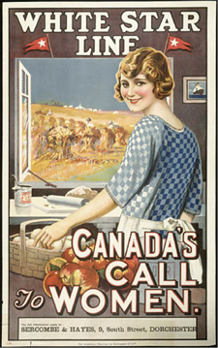
Immigration Project:

Due Date: __________________________________.

- In the 1800s the Canadian Government was desperate to
“PULL” settlers into Canada.

- They used Advertisements to accomplish this.

- They mainly posted ads in European cities to attract settlers.

- Your task: Create an immigration ad that is intended to
attract a specific group of settlers to Canada.

- You may work in partners or on your own for this assignment.

- Your poster can be for the past, present or future!

- Be as creative as possible!

Guidelines:

- You can draw images yourself or use ones from the internet. If you use someone else’s materials (ex: from google) you must source them in a bibliography!

- Your poster must clearly target one specific immigrant group (ex: Italians).

- Your poster must advertise at least one specific PULL factor (ex: free farm land).

- Posters must be visually appealing (colourful, interesting, attractive) in order to encourage immigrants to come to Canada.

- Posters must be accurate (ex: don’t advertise free land in Canada in the year 2013).

