Name: _______________ Mapping European Colonization in North America Date: ________
- This mapping exercise is designed to help you visualize the inroads Europeans made into North America.
- Complete the map below by labeling the following places from your atlas.

Montreal Toronto (York) Quebec City Halifax
Fredericton Prince Edward Island Quebec (Province) Ontario
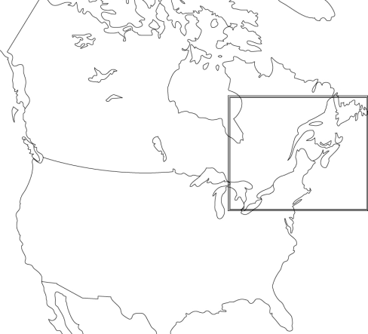
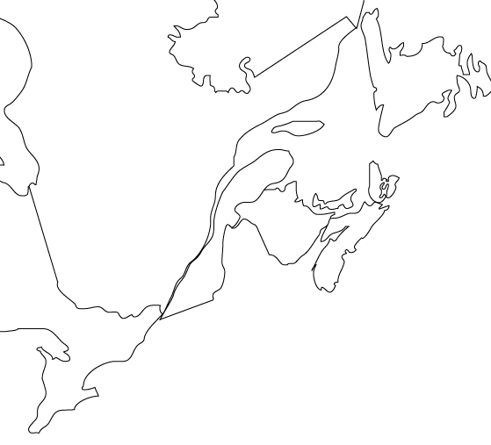
Newfoundland New Brunswick Nova Scotia St. Lawrence River
OVERVIEW of USA and CANADA

- Before European colonization, North America did not have concrete political borders.

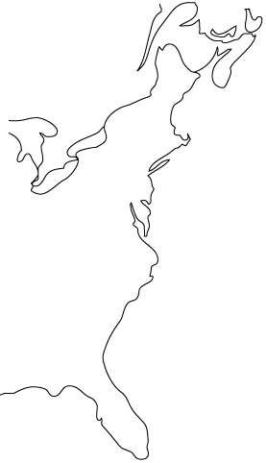
- This changed dramatically after the British and French arrived.

- Complete the map below of the present –day
Eastern United States to help understand how the political
landscape changed.

Label:

New York, Boston, Philadelphia, Washington DC, Florida,
Lake Eire, Lake Huron, Lake Ontario, “Canada,” “United States”

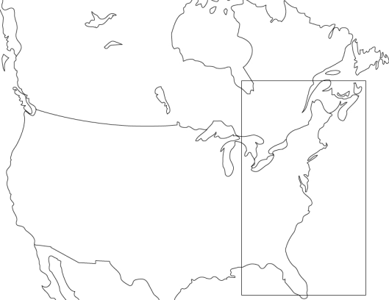
OVERVIEW of USA and CANADA

