MOUNTAIN

SAFETY

HANDOUT

MCj03086590000[1]

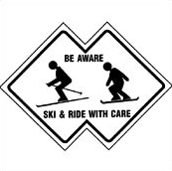

PLAY IT SAFE

Prepared By

Cypress Mountain

**This is For You…**

**PLEASE READ IT!**

This is intended as a basic overview of some important mountain safety information to help you prepare for your trip to the mountain.

Your school has been provided with more detailed information which should be reviewed before your first visit to the mountain.

Snow sports can be dangerous. It is your responsibility to review and follow all safety rules and suggestions in order to have the best experience.

MCj03300890000[1]

MCj03300870000[1]

MCj03525440000[1]

**Don’t Get Caught**

**PLAN AHEAD**

**WEATHER…**

Be prepared for a variety of weather conditions. Mountain weather can change very quickly.

You can check the weather at [www.cypressmountain.com](http://www.cypressmountain.com) or by calling 604-926-5612

**CLOTHING…**

Important items to bring:

* Water resistant jacket & pants
* Warm under layers
* MCj03300910000[1]Gloves (2 pairs)
* Extra socks
* Hat & neck tube
* Goggles
* Sunscreen and sun glasses

**KNOW THE PLAN**

Before getting off of your bus, make sure you know what your group’s plan is. Where and when are you meeting for lessons, lunch, and the bus back home? Do you have a designated meeting area if you get separated from your group?

**Basic Responsibilities**

**MOUNTAIN SAFETY**

**TRAIL MARKINGS…**

These symbols indicate the level of difficulty of a particular trail/run. For your personal safety ***do not go beyond your ability***. If you are unsure of your ability, ask your instructor during your lesson.

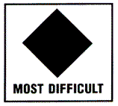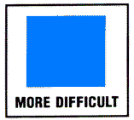

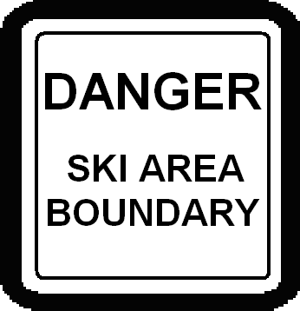**WEATHER and your ABILITY…**

Be aware that changes in the weather can affect your ability. Be especially cautious of icy and hard-packed snow as well as limited visibility.

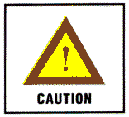

**THE BUDDY SYSTEM…**

**Never ski or ride alone.** If you are not skiing or riding in a group setting with a chaperone, then it is recommended that you ski or ride with a buddy. Always be in visual contact with your buddy.

**Ski Area**

**BOUNDARY MARKINGS**

Boundary markers and ropes outline the controlled area of the mountain. Extremely hazardous terrain lies beyond these markings. ***Do not go beyond the ropes and markings.***

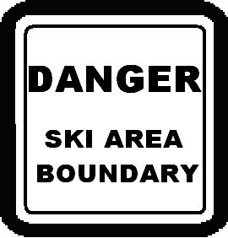

The gullies outside of the boundary get steeper as you descend and often end at cliffs. Do not continue down if you find yourself in such an area.

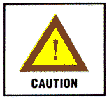

The areas outside of of the boundary are no are not

patrolled by ski

patrol.

**Know what to do…**

**EMERGENCIES**

**Injuries…**

If someone you are with is injured follow these steps…

1. Signal an injury by making an “x” with your ski poles or placing your board across the run 10 meters up the hill
2. Notify staff / patrol or send someone else to do so
3. Stay with the injured person but do not move them
4. Wait for patrol to arrive



**If you are lost…**

If you are lost within the ski area boundary, look for a staff member to show you the right direction or take you to your destination. Always make sure someone knows where you are.

If you are lost outside of the boundary, keep calm. Stay where you are, do not go down, and make yourself as visible as possible.

**RESPONSIBILITY CODE**

Regardless of how you use the slopes, always show courtesy to others.

**ALPINE RESPONSIBILITY CODE**

1. Always stay in control. You must be able to stop and avoid other people or objects.
2. People ahead of you have the right-of-way. It is your responsibility to avoid them.
3. Do not stop where you obstruct a trail or are not visible from above.
4. Before starting downhill or merging onto a trail, look uphill and yield to others.
5. If you are involved in, or witness a collision or accident, you must remain at the scene and identify yourself to the Ski Patrol.
6. Always use proper devices to help prevent runaway equipment.
7. Observe and obey all posted signs and warnings.
8. Keep off of closed trails and closed areas.
9. You must not use lifts or terrain if your ability is impaired through use of alcohol or drugs.
10. You must have sufficient physical dexterity, ability, and knowledge to safely load, ride, and unload lifts. If in doubt, ask the lift attendant.

**HELMETS**

For your safety, it is strongly recommended that you wear a helmet while skiing or snowboarding. Helmets are included as a part of your program and are required for lessons.



**QUESTIONS?**

If you have any questions about mountain safety before your trip, make sure to ask your teacher. Once on the mountain you can also ask your instructor or other mountain staff.

**MCj03086270000[1]**