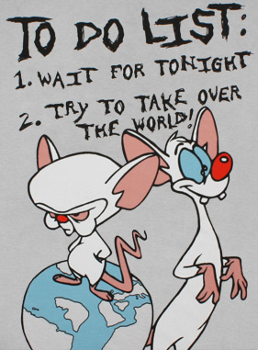
SS 11 Martin Alliances, Empires and the Struggle
Name: ___________ to Divide the World
Date:_________
- A major factor in the onset of war in Europe was the instability brought by
crumbling Empires. These Empires was struggling to control the
burgeoning (growing) Nationalism within their borders while competing
with other Empires for control of the world’s resources.

- Complete this worksheet to better understand the major “Actors” of the
First World War and the motives that behind their decision to begin the
World’s most catastrophic war.

Fall and Rise of Empires:

- List the major Empires and Countries involved in the First World War:

___________________,___________________, ___________________, ___________________

___________________,___________________, ___________________, ___________________

Ideology and Political Movements:

- As we discussed last class, political movements had a great influence on the stability of Empires.
- Complete the table below to better understand the notions that captivated 20th Century Europeans.
Nationalism: | List Three 20th Century Examples | List Three Modern Day Examples | Describe how this contributed to the start of WWI:
Imperialism: | List Two 20th Century Examples | List One Modern Day Example | Describe how this contributed to the start of WWI:
Militarism: | List Three 20th Century Examples | List One Modern Day Example | Describe how this contributed to the start of WWI:

