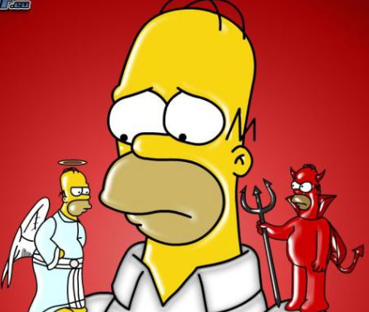
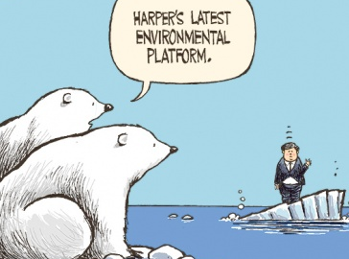
THE ELECTORAL
PROCESS IN
CANADA

Name: __________________

Date:_________ Block : ______

- Federal and Provincial Elections occer every ____________ in Canada.

- Municipal elections are called every _________ in BC (_________________________)

* WAIT!? Why then did we have elections in 2006, 2008, 2011 and 2015 Federally?

- Because: ________________________________________________________________.

How Are Elections Run in Canada?

Step 1: The _______________________________ diossolves Parliament when either:

- _______________________________________________________________________.
- _______________________________________________________________________.
- _______________________________________________________________________.
Step 2: An election is now scheduled ________________________________________.
Step 3: The Prime-Minister ________________________________________________.

Election Timeline (28 Days Later?!)
Day 0

Day 0 – 7

Day 7 – 28

Day 22 – 25

Day 28

* Note: Recounts (situations where a candidate wins a seat by 100 votes or less) can take approx 10 days to complete

Voting In a Federal Election

- Anyone who is _______ or older on Election Day and registered with Elections Canada can vote. New voters can register at polling stations on Election Day. Easiest way to register? ____________________________________.
- Canadians can cast their votes in numerous ways:

- _________________________ (85% chose this option).
- _________________________ (10% of voters). 3) _________________________ (5% of voters).
- Votes are cast in __________________ format. In order to win a seat a candidate must receive the most votes in their constituency (____________________________________________________________________________)
- This system is called “ ___________________________________________________________.”
- Candidates are not allowed at voting stations (bullies?) but they may send a ____________________ to observe.

Election Campaigns in Canada

- The house of commons has ______ seats. Each seat represents a _________________ of aprx _______.
  - Most candidates run under the banner of a ______________________.
  - However candidates may also run as ___________________________.
- In order to run for a party you must be _________________________, which costs ________________.
- To make elections as fair as possible, parties and candidates must abide by the ____________________.
- This Act limits the amount of $ an individual or party may spend on their campaign. Also candidates must carefully record the amount they spend and where they got the $ from.
- What are some potential campaign methods for candidates?
_____________________________________________________________________________________
