Mr. Martin SS 10

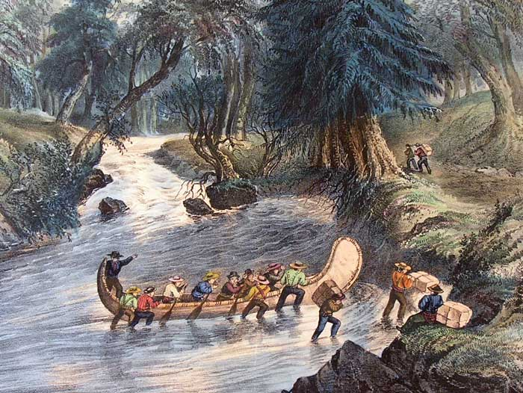
Name: ___________________

Date: ______________

Unit #6: Expanding West

Unit Goal: Students will be able to explain how
and why Canada expanded westward in the
latter half of the 19th Century.

Unit Objective #1: Students will be able to
explain how European settlers interacted with
First Nations Peoples in Canada.

Unit Objective #2: Students will be able to explain how the Fur Trade influenced Canada’s expansion westward from 1815 – 1914.

Today’s Lesson: The Fur Trade in Canada

Introduction: True/False Pop Quiz

1) During the year 2012, the Canadian Government reported sales of over $300 Million in fur exports? (T / F)

2) Due to overhunting by the fur trade in the 1800s, foxes are now extinct in Canada, east of Manitoba? (T / F)

3) On March 20, 1869, the Hudson's Bay Company sold Rupert's Land (A chunk of land over 8 million square
kilometres) to the Government of Canada for $50 million? (T / F)

4) In 1867, the United States purchased Alaska from Russia for $7.5? (T / F)

The Fur Trade in Canada:

- Early European Explorers were interested in these three lucrative industries in Canada:

__________________, __________________, __________________,

- Why was European settlement important for the success of the Fur Trade in Canada?

___________________________________________________________________________________.

- The three main animals trapped for their fur in Canada during the 1800s were:

__________________, __________________, __________________,

- Fur was a valuable trade good because: ________________________________________________.

Groups Involved in the Fur Trade:

- Europeans relied heavily on _______________________________ to assist them in the fur trade.

- First Nations Peoples were interested in trading ____________________, ___________________

_____________________ and ______________________ for fur pelts with the Europeans.

- However, a major issue for the F.N. Peoples who traded with Europeans was:

__________________________________________________________________________________.

- The two main trading companies in Canada were known as: ______________________________

and __________________________________.

- Who were the voyageurs? _________________________________________________________.

- What key role did they play in Canadian society? _______________________________________

__________________________________________________________________________________.

- Define the word Portage: __________________________________________________________

__________________________________________________________________________________.

- Competition between the two big trading companies ended in the year _____________ because:

__________________________________________________________________________________

__________________________________________________________________________________.

- The surviving company was named: ____________ and is still the __________ public company in North America (although it was sold to an American Company in 2008).

Exit Slip Question:
Imagine yourself as a First Nations Villager in the 1800s. During a winter storm, a group of 5 voyageurs becomes stranded near your village. You have had minimal contact with the European fur traders before. If you ignore them, they might die from starvation or exposure to cold.
Would you risk the safety of your small village by helping the stranded Europeans, or would you ignore them and remain hidden from the European world? Explain your answer in a 5-7 sentence paragraph.

