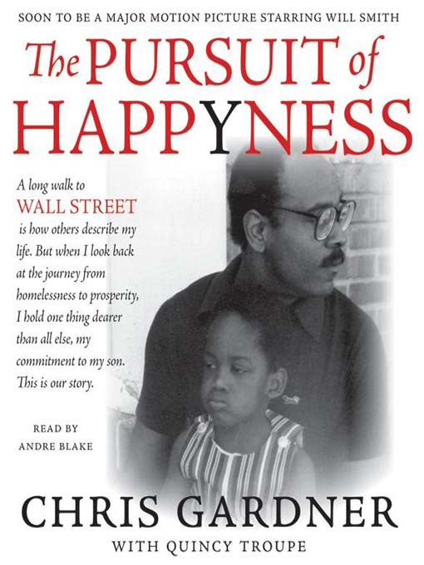
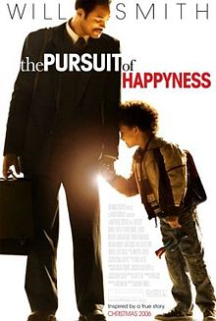

In this course we are reminded that God is within us and is ever present when it comes to our families. We have learned that both parents and children have responsibilities to one another to make each individual the best person they can be. We also know that humans are fallible (imperfect) and that we try to limit the number of mistakes we make in our lives.
In the movie “The Pursuit of Happiness,” which is based on a true story, a family goes through some tough times and had to make some difficult decisions. The father’s name is Chris Gardner and the mother’s name is Linda and they have a 5 year old son named Christopher.
Your Task:
In a short essay (500 words aka 2 pages typed/double spaced) you will need to identify both positive and negative qualities of this family. In order to do so you will have to refer to chapter 9 to identify attributes (characteristics) which are evident in the film. In addition to this, you will need to express your overall impression of Chris Gardner as a father.
Suggestion: Intro, 1 paragraph positive, 1 paragraph negative, 1 paragraph on Gardner, conclusion.
While watching the movie it may be to your advantage to have your textbook out and to take some notes to highlight certain examples from the movie.
This assignment needs to be typed and double spaced.
Total Marks: 20

