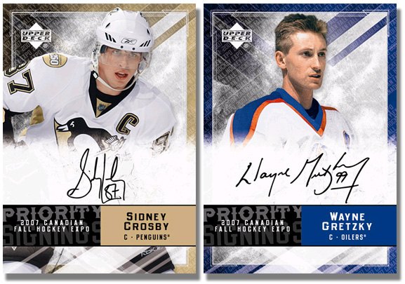
Name: _____________________ Due Date: ___________

Characters of the French
Revolution Hockey Cards Project:

Objective: Develop and understanding of the significance
of key actors in the French Revolution.

Your task:

- Create a deck of hockey cards that meets the minimum 20 points in value.
- You must choose at least one person from each category

Player Values: Each player is worth a specific value

Gold – 4 Points Silver – 3 Points Bronze – 2 Points

Louis XVI Rousseau Louis XIV
Marie Antoinette Voltaire Louis XV
Napoleon Bonaparte Montesquieu Madame Roland
Max Robespierre Alexis De Tocqueville Madame De Pompadour
Jean-Paul Marat Isaac Newton Count Mirabeau
Jacques Danton John Locke AR Turgot
Jacques Necker
Charlotte Corday

- If you think of any other significant actors, run them by me for valuation.

REQUIRED INFORMATION - Each Card Needs the following:
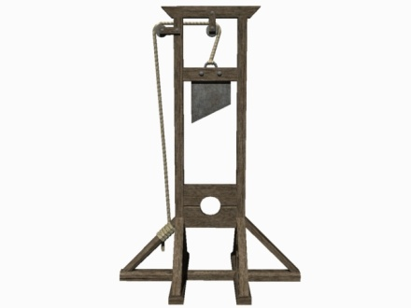
Front of Card:

- Main Image with Name (hand drawn or use computer)

Back of Card:

- Approximate birth date
- Birthplace
** Summary of 3 important deeds or actions (2-3 sentences max).
In other words, why they are famous **

- This is an individual assignment.
- Be as creative and colourful as possible! Include any “stats” you want.
- The most important part of the card is the summary of their deeds.
- Graded out of 25 marks – Hand in the rubric on the back of this page with the cards.

Name: ___________________ Block: ___________ Date: ________________
Hockey Cards Rubric | Exceeds Expectations | Meeting  Expectations | Approaching Expectations | Does Not Meet Expectations | Section Total:
Neatness and Appearance  - Cards are easy to read, appealing to the eye and completed with care  - Cards are colourful, organized and include a main image  - Images are accurate and easy to understand |  |  |  |  | / 5
Content  - Deck of cards is worth a minimum of 25 points  - At least 1 selection from Gold, Silver and Bronze  - Name of person clearly stated  - Approx date of birth, death and birth place stated |  |  |  |  | / 5
Creativity and Originality  - Cards display uniqueness, originality and creative thinking |  |  |  |  | / 5
Summaries  - Summaries include 3 facts about each person  - Summaries are accurate and relevant  - Summaries display evidence of research and understanding of key topics |  |  |  |  | / 10
Additional Comments: |  |  |  | Total: | /25

