 **Social Studies 9**

**Course Outline**

**2016-2017**

**EVALUATION and TASKS:**

Grading is on a linear scale, meaning, the learners’ grade will flow throughout the year. The final grade will be the June report card, with three interim reporting periods throughout the year. Evaluations will be based on the following assignments:

* 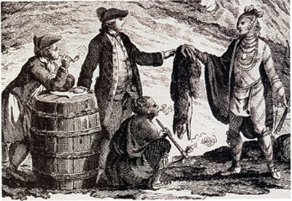Exam
* Written Assignments
* Tests/Quizzes
* Oral Presentations and Skills
* Critical Analysis and Thinking Skills
* Technology Development
* Unit Tests
* Current Events
* Independent Reading



**Contacting Me:**

The best way to contact me with questions is by email: [vmartin@ndrs.org](mailto:vmartin@ndrs.org)

Responsible students will always come see me in person or email me when they are absent. I always do my best to respond to emails in a timely manner.

Homework updates, downloads and deadlines are available on my website:

<http://www.vpmartin.weebly.com>

I will also be using remind to send text or email reminders. You still need to do your own scheduling! Do not expect me to schedule your life for you!

## The code to join remind in SS 9 is: “@martinss9” to the number (778) 654-0431

I look forward to a successful year with each and every one of you! ☺