Name: ________________ Time Zones Across the Globe: Date: _________ Social Studies 9
- The world is split up into numerous time zones to reflect the fact that the sun’s rotation effects different parts of the globe at certain times.
- Being such a large nation, Canada has 6 time zones.
- The map below reflects the world’s time zones. The Greenwich Meridian is the most important line, as it is considered the starting point.
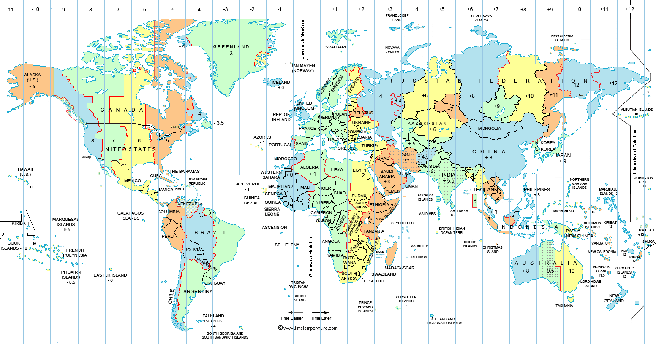
- Complete the questions below to practice calculating time zones across the globe.

If it is 12:00pm (noon) in Greenwich what time is it in Vancouver? _________
If it is 12:00pm (noon) in Greenwich what time is it in Germany? _________
If it is 12:00pm (noon) in Greenwich what time is it in China? _________
If it is 6pm in Vancouver what time is it in Seattle, Washington? _________
If it is 2:00pm in Vancouver what time is it in Sydney, Australia? ___________
If it is 4:00pm in Montreal what time is it in Santiago, Chile? ___________
If it is 10:00am in Toronto what time is it in Anchorage, Alaska? ___________
If it is 6:00am in Calgary what time is it in Tokyo, Japan? ___________

