Name: ___________ The Industrial Revolution in Britain Date:_____ SS9

Questions from the first part of the video “Why the Industrial Revolution Happened in Great Britain”
1. How would you define the “Industrial Revolution?”

2. What were the key results (for Britain) of the Industrial Revolution?

Questions from Crossroads Ch. 5:
3. Based on the timeline on p. 128, during what years did the Industrial Revolution have its greatest effects?

4. Read the Introduction on p. 129. Why was the Industrial Revolution important? What was the legacy (long-term impact) of the Industrial Revolution?

5. Read the Why Britain section on p. 129-130. What did this nation have that made it a good place for industrialization? What were the early effects of the Industrial Revolution on ordinary people?

6. What was the purpose in having and developing colonies? What important commodities did mother-countries gain from colonies?

Mapping Europe in the early 1800s:

Use an atlas, or an online source to locate the following, keeping in mind that the borders have changed over the last 200 years:

England ∆, Scotland ∆, Wales ∆, Ireland ∆, France ∆, Spain ∆, Norway ∆, Sweden ∆, Netherlands ∆
Russia ∆, Austria-Hungary ∆, the Ottoman Empire ∆, the Germany ∆, and Italy ∆.

Label the North Sea ∆, the Baltic Sea ∆, the Black Sea ∆, Mediterranean Sea ∆, and the Atlantic Ocean ∆.

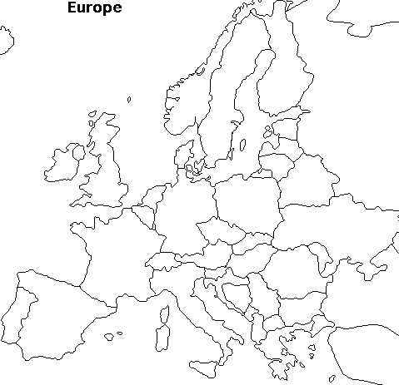
You can tick the triangles when you find and label each item above.

