Regionalism in Canada: Western Alienation and Independence

The Year is 2020. Western Canada, tired of being controlled by Ottawa for years, is on the verge of a Unilateral Declaration of Independence, as was Quebec in the latter part of the 20th Century.

The feelings in the west vary: some want complete independence, some are looking for a sovereignty-association deal with the rest of Canada, while others look to join the United States of America. You are a senior politician and someone whose opinion is valued in the west. You have been asked to give a presentation to western political and business leaders during which you will tell them what you think the west should do.
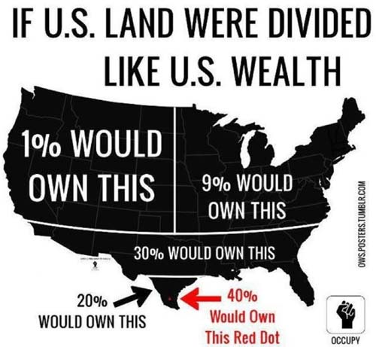
Complete independence?
A new kind of relationship with the rest of Canada?
A new deal with the USA?
What do you think is the best thing to do?

Think in terms of the following:
· Who are we closest to, geographically?
· What sort of resources does the west have, and can we afford to leave Canada?
· What current provinces and territories are “the west”
· What would we use for currency?
· Who would protect us?
· Where would the capital be? (if you thought independence was the best bet)
· Would you redraw borders?
· What would be the name of this new country? (if you chose independence)
· Are westerners “different” than other Canadians?

The presentation could be a speech, a slide-show, a report; whatever you feel could best present this material. Visuals are a great tool! Whichever you choose, you must deal with the following 4 concepts: Geography, Culture, Government and Economics. **

Overall Question to answer: What Would The New Independent British Columbia Look Like?

Work Alone, in 3s or 4s. Maximum is 4. Don’t even ask.

NAME(S): ________________________________________

Rubric: Western Separatism - TOTAL : / 40 | Exceeds Expectations | Meeting Expectations | Approaching Expectations | Does Not Meet Expectations
Creativity
-Student shows evidence of creativity, thinking outside the box and problem solving.
-Anticipate issues that would arise from Separatism. / 10
Persuasiveness
-Makes clear arguments about why Separatism is necessary for BC.
-After hearing your arguments the audience can understand your perspective and rationale for Separation. / 10
Geography Section
-Answers the questions: “What will BC’s new Geography look like” “What will the effects of independence be on this sector?” / 5
Culture Section
-Answers the question: “What will BC’s new Culture look like” “What will the effects of independence be on this sector?” / 5
Government Section
Answers the question: “What will BC’s new Government look like” “What will the effects of independence be on this sector?” / 5
Economics Section
-Answers the question: “What will BC’s new Economy look like” “What will the effects of independence be on this sector?” / 5
