Name: Second World War Mapping Assignment Date:
(See reverse for instructions)
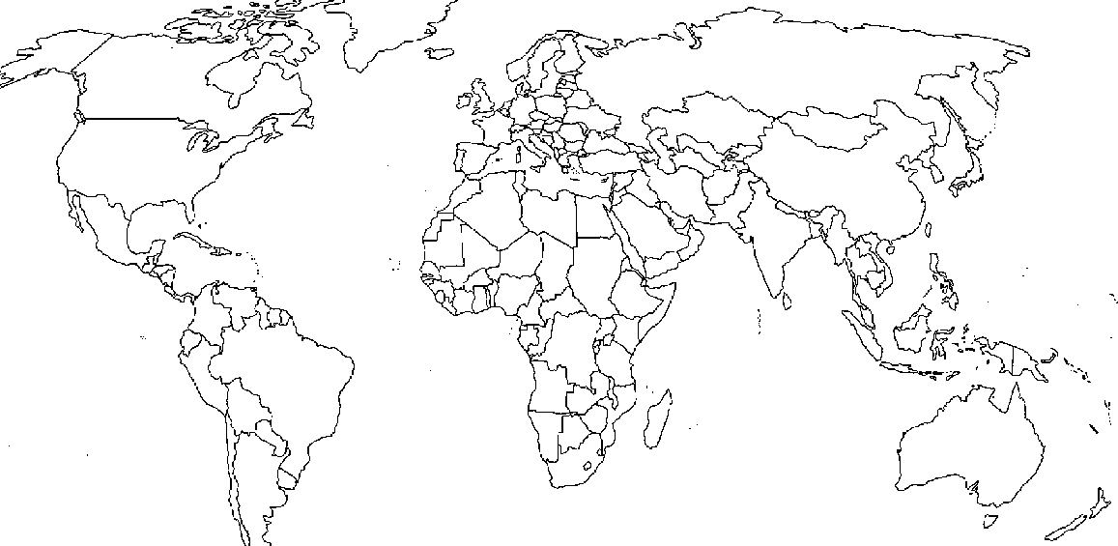

Instructions:
- Place the following cities and battle locations on the map provided. Use colour to label them. A different colour for each category.

Cities important during WWII
· Singapore · Rome · Stalingrad (Volgograd) · Halifax · Dresden · Krakow · Hamburg · Hiroshima · London · Warsaw · Manila · Leningrad · Nagasaki · Moscow · Berlin

Places the Allies held Conferences
· Yalta · Quebec City · Casablanca · Tehran

Location of Concentration/Death Camps
· Bergen Belsen · Auschwitz · Plaszow · Buchenwald · Dachau · Treblinka

Identify where the following key battles occurred
· Battle of Bulge · Iwo Jima · Battle of Britain · Kursk · El Alamein · Scheldt · Pearl Harbour · Coral Sea · Dieppe · D Day · Hong Kong · Ortona

Research Assignment

Choose one of the above battles or another one of your choice (check with the teacher first) and give a W5 (who, what, when, where, why) on the topic.
Include battle plans, geographic features etc. Who was involved? Why was it fought? What was the outcome? Include casualties, what branches of the Armed Forces were involved, anything you think is important. Please include a list of your references.

Hint: Start with the atlases, Counterpoints (Prentice Hall) pp. 103-104, 106-114, 116-122, 126 and your workbooks for assistance.

Name of Battle: ___________________
Who Was involved? | When (what  time periods?) | What Happened? | Where (describe the geographic features) | Why did this battle occur? What outcomes were each side hoping for?

